**If you feel your brine shrimp movies did not turn out well you can substitute movies on one or two of the following.**

**1. Freshwater isopod.** Obtain a photograph, label regions, and describe how appendages are used in locomotion.As in most crustaceans, the isopod body is divided into three distinct regions: **head** (= **cephalon**), **thorax (=pereon)**, and **abdomen** (= **pleon**). Please use the more general terms, head, thorax and abdomen for labels on your photograph.

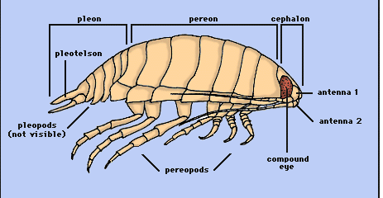

**2. Freshwater or saltwater amphipods. Please do not mix saltwater and freshwater cultures. Rinse containers that have been used to view saltwater organisms.**

Obtain a photograph and label regions, head, thorax and abdomen. Describe how appendages are used in locomotion.

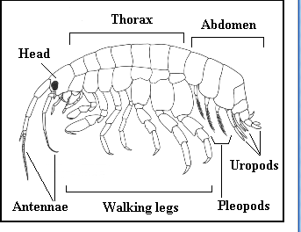

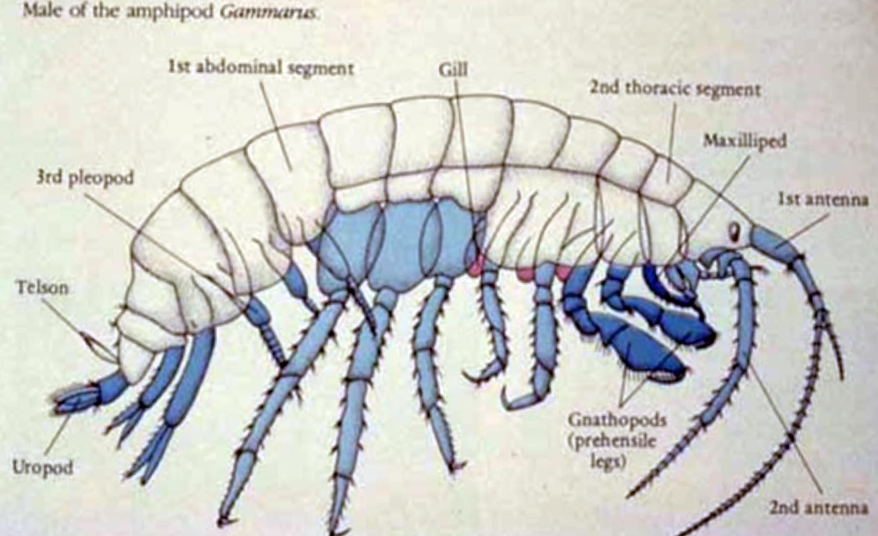

**3. Pillbugs**

Examine the pill bugs or land isopods available. There are several species of varying size and color that are living happily together in an aquarium. All are US natives.

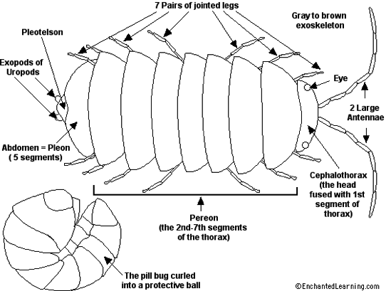

Compare its morphology to the fresh water amphipod or isopod that you observed.

How do pillbugs use their legs to walk on land? How many legs are moved in tandem? How do they use their legs to move over obstacles?

**Your journal at the end of this activity should contain photographs of body segments (head, abdomen, etc.) and heart and gills for transparent specimens. There should be a movie on locomotion for Daphnia or brine shrimp, already in your journal from lab 1. I expect notes comparing in detail, how the specimens you viewed, whether they are Daphnia, brine shrimp or the substitute crustaceans locomote.**